- Configure 2 slave machines in Jenkins master.

1. Prerequisites

Before starting, ensure the following are available:

### **Jenkins Master**

* Jenkins installed and running on a master node
* Admin access to Jenkins
* Jenkins URL accessible from slave machines
* Java (JDK 8/11/17) installed

### **Slave (Agent) Machines – 2 Nodes**

* Linux/Windows machines (recommended: Linux)
* Java installed (`java -version`)
* Network connectivity to Jenkins master (port **8080** or configured port)

### **Jenkins Plugins**

* **SSH Build Agents Plugin** (Manage Jenkins → Plugins → Available)

2. Step-by-Step Implementation

### **Step 1: Install Java and create “ssh-keygen” on Both Slave Machines**

```bash
sudo yum update -y
sudo dnf install java-17-amazon-corretto -y
java -version

Create ssh-keygen
cat id_rsa.pub > authorized_keys (this command used to add the “ssh-keygen” to “authorized_keys” )
chmod 700 authorized_keys
```
SLAVE-1

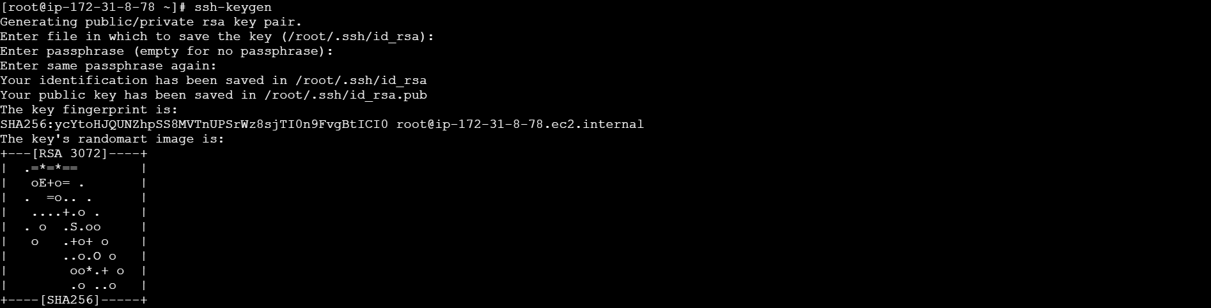
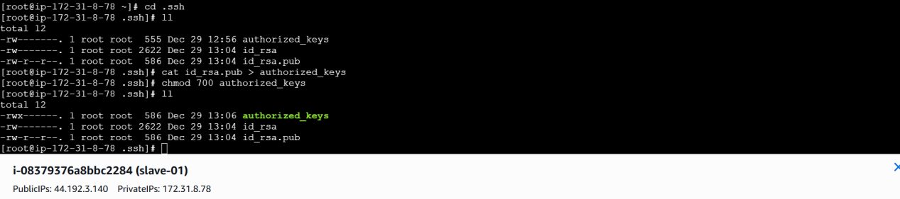

SLAVE-2

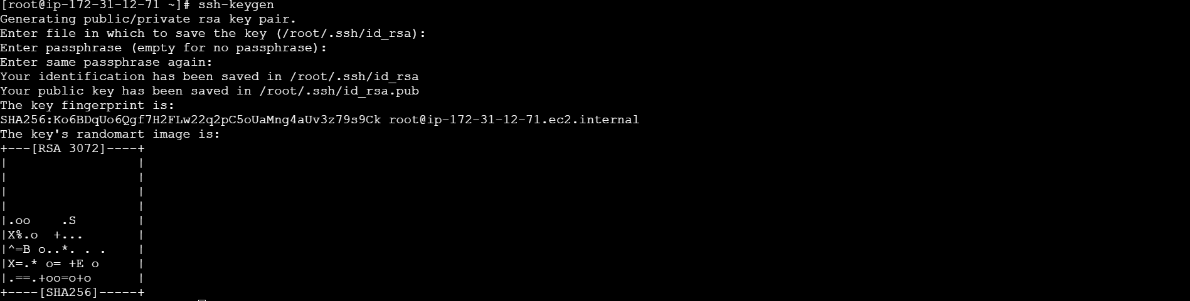
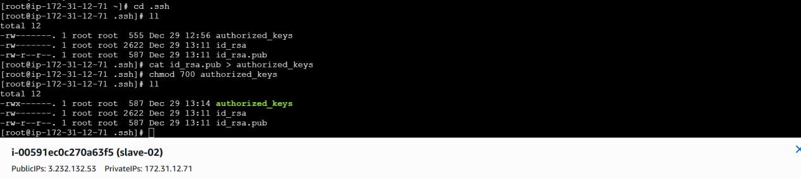

### **Step 2: Login to jenkins master machine**

##CREATE A DIRECTORY “.ssh” in /var/lib/jenkins

mkdir -p /var/lib/jenkins/.ssh
cd /var/lib/jenkins/.ssh

##The below command is used to copy the authorized_keys of the host or ip to known_hosts from both slaves.

ssh-keyscan -H (SLAVE-NODE-IP-OR-HOSTNAME) >>/var/lib/jenkins/.ssh/known_hosts

##we need to change the owner as we ran ssh-keyscan command using “root” user, default user of Jenkins will be “jenkins”

chown jenkins:jenkins known_hosts

chmod 700 known_hosts (giving permissions)
```
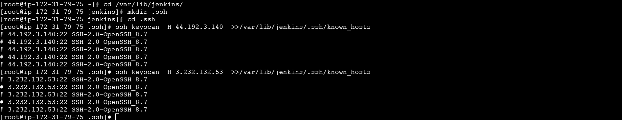
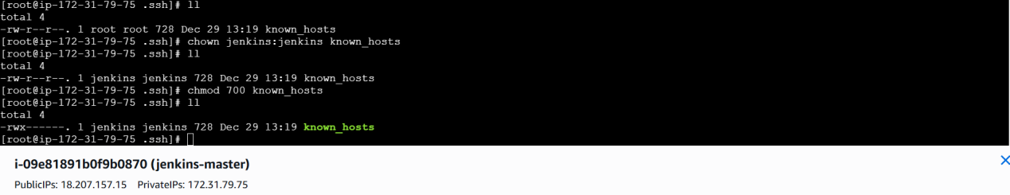

### **Step 5: Configure Jenkins Node (Agent 1)**

1. Go to **Jenkins Dashboard**
2. Click **Manage Jenkins → Nodes and Clouds**
3. Click **New Node**
4. Enter:

* Node name: `agent-1`
* Type: **Permanent Agent**
5. Configure:

* **Remote root directory**: `/home/ec2-user`
* **Labels**: optional
* **Usage**: Use this node as much as possible
* **Launch method**: Launch agents via SSH
* **Host**: `<slave1-ip>`
* **Credentials**: Add SSH credentials
6. Click **Save**

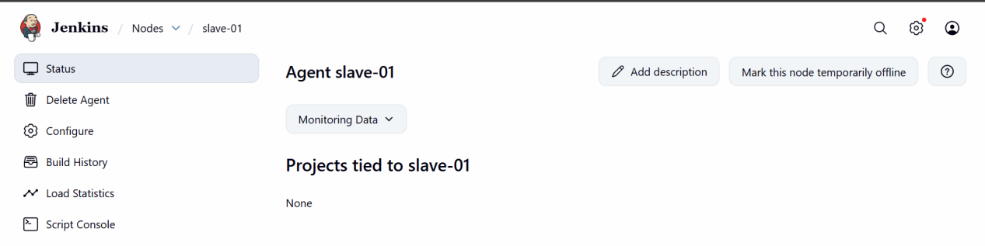

### **Step 6: Configure Jenkins Node (Agent 2)**

Repeat the same steps for **agent-2**:

* Node name: `agent-2`
* Host: `<slave2-ip>`

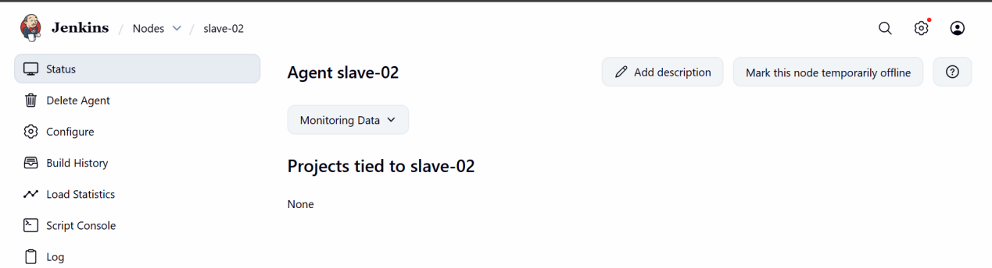

### **Step 7: Verify Agent Connection**

* Go to **Manage Jenkins → Nodes**
* Both agents should show **Connected / Online**

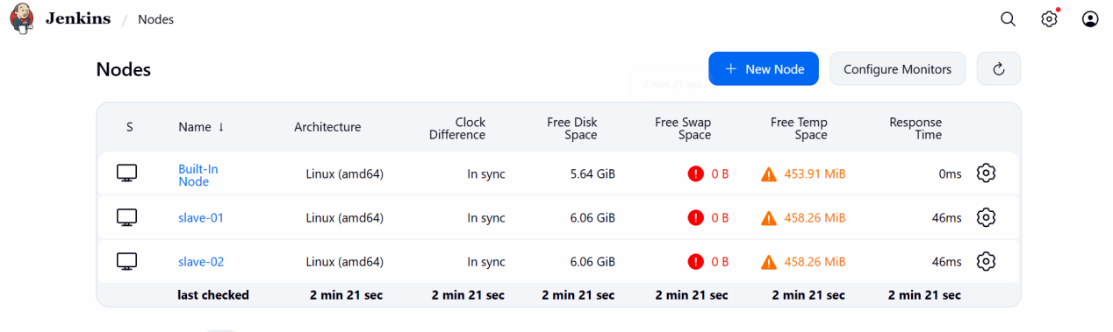

3. Validation Steps

✔ Jenkins master can connect to both agents
✔ Agents show **Online** status
✔ Jobs run successfully on both nodes
✔ Workspace created under `/home/jenkins`

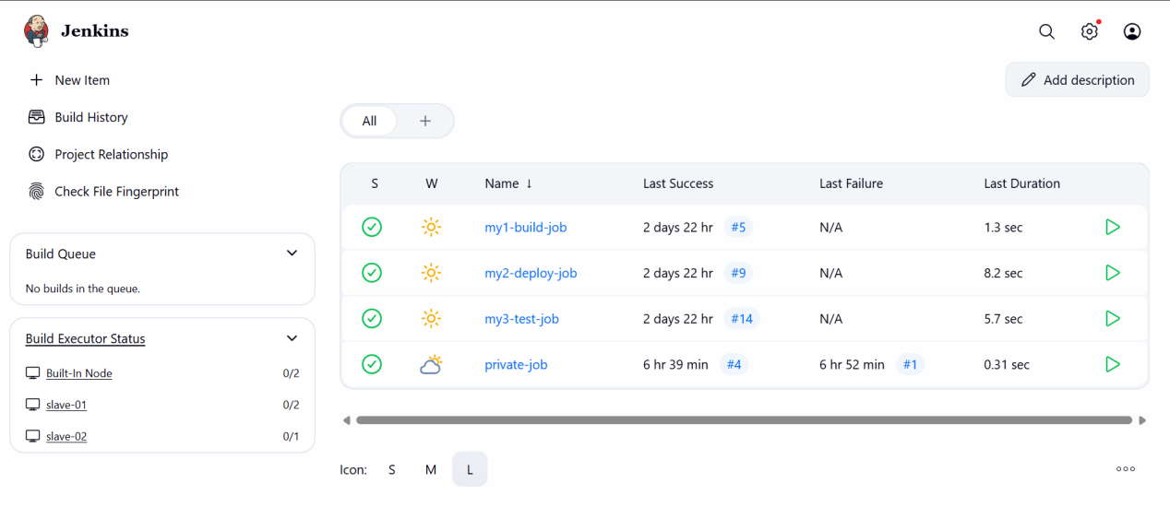

4. Conclusion

Two Jenkins slave machines were successfully configured and connected to the Jenkins master, allowing distributed job execution and improved build performance.

- Configure webhooks to Jenkins job.

1. Prerequisites

Before starting, ensure the following:

### **Jenkins Side**

* Jenkins is running and accessible via public IP or DNS
* Jenkins job already created (Freestyle or Pipeline)
* **GitHub plugin** installed
* **Git plugin** installed

📍 Check:
`Manage Jenkins → Plugins → Installed`

### **GitHub Side**

* GitHub repository (public or private)
* Admin access to the repository
* Jenkins URL reachable from GitHub (no firewall blocking)

Example:

```
http://<jenkins-ip>:8080
```

2. Step-by-Step Implementation

### **Step 1: Configure Jenkins Job**

1. Go to **Jenkins Dashboard**

2. Open your job → **Configure**

3. Under **Source Code Management**

* Select **Git**
* Repository URL:

```
https://github.com/<username>/<repo>.git
```
* Add credentials if private repo

4. Under **Build Triggers**
✅ Check **GitHub hook trigger for GITScm polling**

5. Save the job

### **Step 2: Enable GitHub Webhook in Repository**

1. Open your GitHub repository

2. Go to **Settings → Webhooks**

3. Click **Add webhook**

4. Configure:

* **Payload URL:**

```
http://<jenkins-ip>:8080/github-webhook/
```
* **Content type:** `application/json`
* **Secret:** (optional)
* **Which events would you like to trigger this webhook?**
→ Select **Just the push event**

5. Click **Add webhook**

✅ GitHub will send a test payload automatically.

### **Step 3: Verify Webhook Delivery**

1. In GitHub:

* Go to **Settings → Webhooks**
* Click the webhook
* Check **Recent Deliveries**
* Status should be **200 OK**

2. In Jenkins:

* Go to job → **Build History**
* A build should trigger automatically

### **Step 4: Test with Code Push**

```bash
git add .
git commit -m "Testing Jenkins webhook"
git push origin main
```

✔ Jenkins job should start automatically.

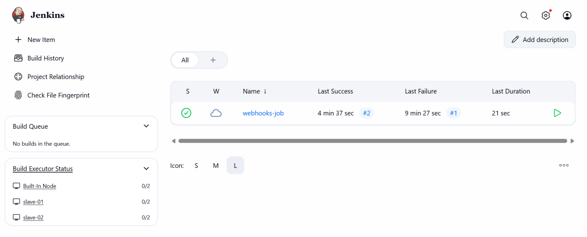

3. Validation Steps

✔ Webhook delivery shows **200 OK**
✔ Jenkins job triggers automatically on git push
✔ Console output shows SCM checkout
✔ No manual build required

4. Conclusion

The Jenkins job has been successfully integrated with GitHub using webhooks, enabling automatic build execution whenever code is pushed to the repository.

- Configure poll scm and build periodical options in Jenkins job.

1. Prerequisites

Before configuring triggers, ensure the following:

* Jenkins is installed and running
* A Jenkins job (Freestyle or Pipeline) already exists
* Source code repository (GitHub/GitLab) is configured in the job
* Jenkins server has access to the repository
* Git plugin is installed

2. Step-by-Step Implementation

## **A. Configure Poll SCM**

👉 **Purpose:**
Jenkins checks the SCM at a fixed interval and triggers a build **only if changes are detected**.

### **Steps:**

1. Go to **Jenkins Dashboard**
2. Open your job → Click **Configure**
3. Scroll to **Build Triggers**
4. Check ✅ **Poll SCM**
5. Enter a cron schedule (example below):

```
H/5 * * * *
```

Meaning:

* Jenkins checks SCM every **5 minutes**
* Build triggers only if code changes exist

6. Click **Save**

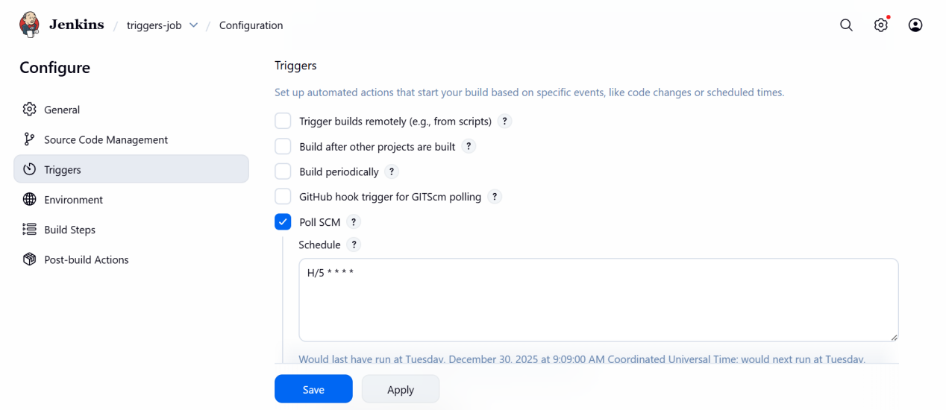

## **B. Configure Build Periodically**

**Purpose:**
Jenkins triggers a build at fixed intervals **regardless of code changes**.

### **Steps:**

1. Open the same job → Click **Configure**
2. Under **Build Triggers**
3. Check ✅ **Build periodically**
4. Enter a cron schedule:

```
H 15 * * *
```

Meaning:

* Build runs **once every day at 3 PM**

5. Click **Save**
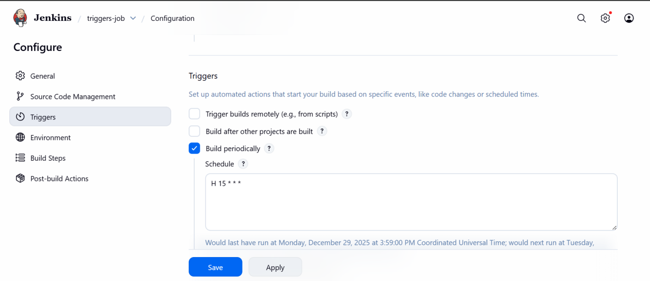

## **3. Cron Syntax Reference**

| Expression | Meaning |
| ----------- | ------------------------------- |
| `*` | Every unit |
| `H` | Hash value (spread load evenly) |
| `*/10` | Every 10 units |
| `H/15` | Every 15 minutes |
| `0 0 * * 0` | Every Sunday midnight |

4. Validation Steps

### **For Poll SCM**

✔ Make a commit and push to repository
✔ Jenkins automatically triggers build
✔ Console output shows:

```
Started by an SCM change
```

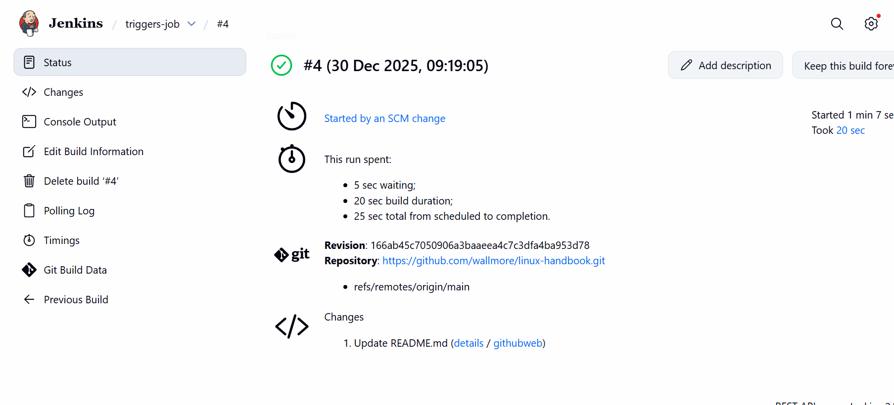

### **For Build Periodically**

✔ Wait until scheduled time
✔ Jenkins triggers build automatically
✔ Console output shows:

```
Started by timer
```
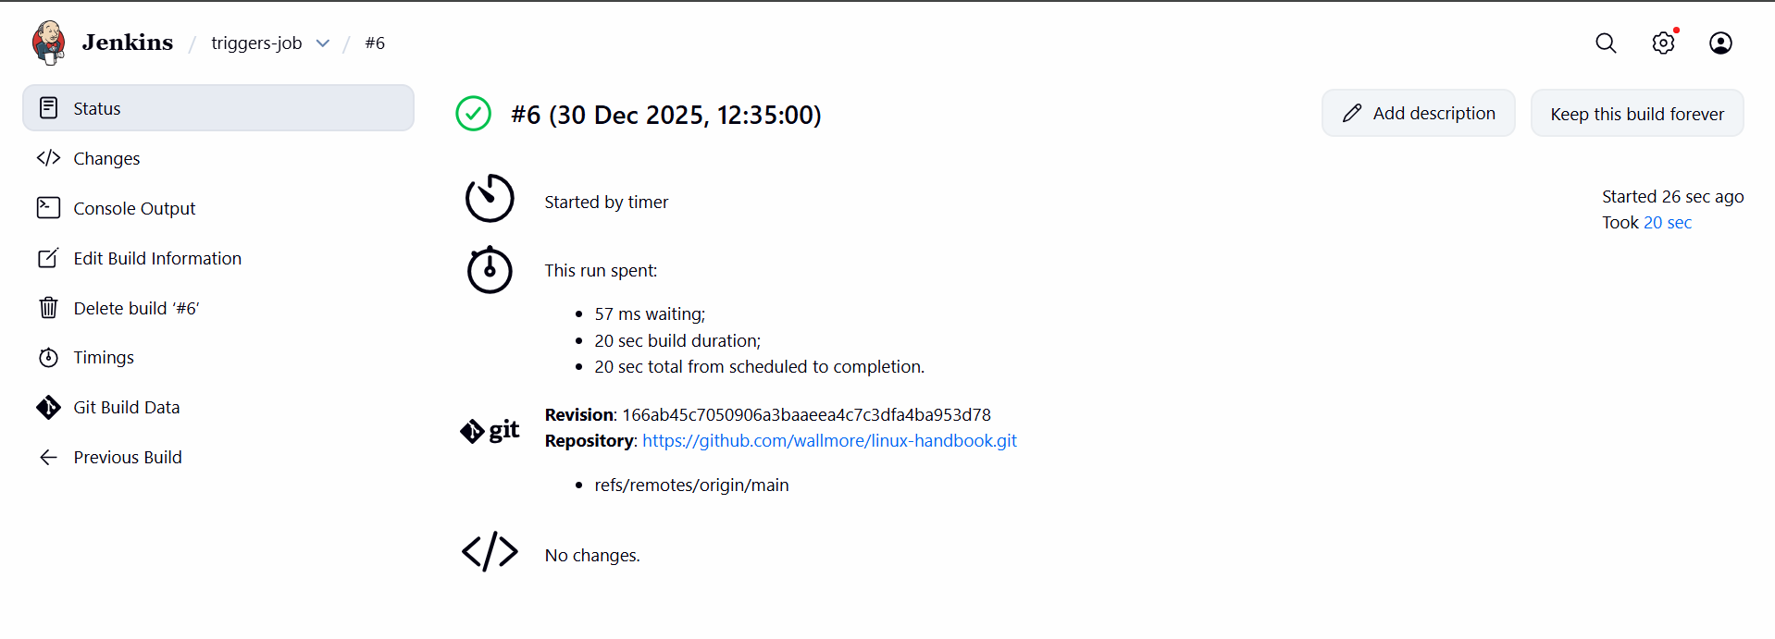

5. Conclusion

Poll SCM and Build Periodically triggers were successfully configured, enabling Jenkins to automatically run jobs based on source code changes and scheduled intervals.

- Take backup of Jenkins server by using bash script.

1. Prerequisites

Before taking a Jenkins backup, ensure the following:

* Jenkins installed and running
* Linux server access with **sudo/root** privileges
* Sufficient disk space for backup storage
* Location of Jenkins home directory (default):

```
/var/lib/jenkins
```
* `tar` and `gzip` utilities installed (usually pre-installed)

2. Step-by-Step Implementation

### Step 1 : Create Backup Script
vi jenkins_backup.sh

Paste the Script Below

#!/bin/bash

# Variables
JENKINS_HOME="/var/lib/jenkins"
BACKUP_DIR="/backup/jenkins"
BACKUP_FILE="jenkins_backup.tar.gz"

# Create backup directory if not exists
mkdir -p $BACKUP_DIR

# Stop Jenkins service
echo "Stopping Jenkins..."
sudo systemctl stop jenkins

# Create backup
echo "Taking Jenkins backup..."
tar -czf $BACKUP_DIR/$BACKUP_FILE $JENKINS_HOME

# Start Jenkins service
echo "Starting Jenkins..."
sudo systemctl start jenkins

# Verify backup
if [ -f "$BACKUP_DIR/$BACKUP_FILE" ]; then
echo "Backup successful: $BACKUP_DIR/$BACKUP_FILE"
else
echo "Backup failed!"
fi

#### Step 2 : Make Script Executable
chmod +x jenkins_backup.sh

#### Step 3 : Run the Backup Script
sudo ./jenkins_backup.sh

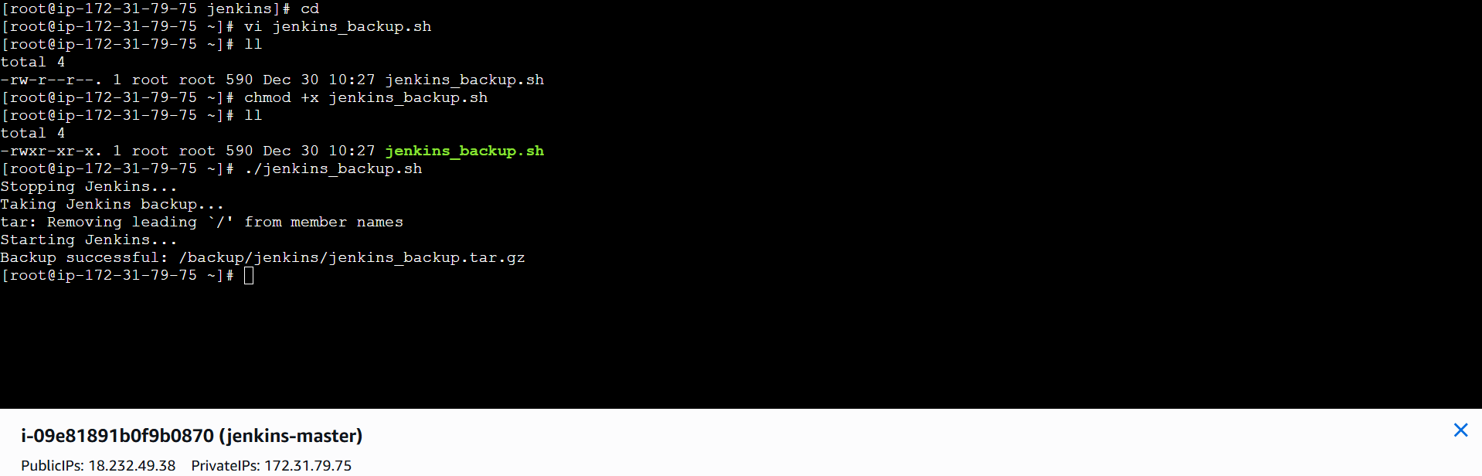

#### Step 4 : Verify Backup
ls -lh /backup/jenkins/

You should see:

jenkins_backup.tar.gz

3. Validation Steps

✔ Backup file created in `/opt/jenkins_backup`
✔ Jenkins service stops and starts successfully
✔ Backup archive contains jobs, plugins, config files

Check backup:

```bash
ls -lh /backup/jenkins/
```

4. Conclusion

The Jenkins server backup was successfully created using a Bash script, ensuring safe storage of jobs, configurations, and plugins for recovery purposes.

- Take backup of Jenkins using rethin backup plugin.

1. Prerequisites

Before starting, ensure the following:

* Jenkins is installed and running
* Admin access to Jenkins
* Enough disk space for backups
* Internet access (to install plugin)

2. Step-by-Step Implementation

## **Step 1: Install ThinBackup Plugin**

1. Go to **Jenkins Dashboard**
2. Click **Manage Jenkins → Manage Plugins**
3. Open **Available** tab
4. Search for **ThinBackup**
5. Select **ThinBackup Plugin**
6. Click **Install without restart** (or restart if prompted)

✅ Plugin installed successfully.

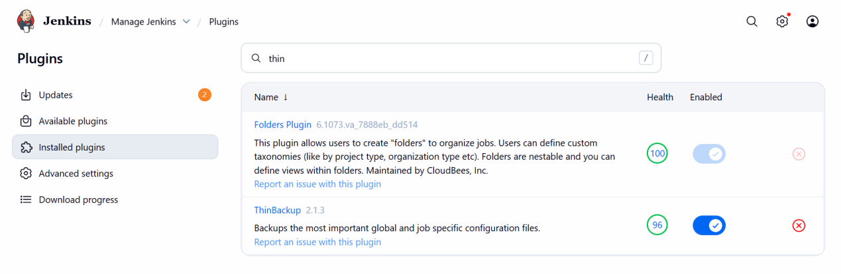

## **Step 2: Configure ThinBackup**

1. Go to:

=== Create one directory for backups
```
Manage Jenkins → System →ThinBackup configurations
```

### Configure the following:

| Setting | Value |
| ------------------------- | ---------------------------------- |
| Backup directory | `/opt/jenkins_thinbackup` |
| Backup schedule | (Optional – leave empty if manual) |
| Max number of backup sets | `7` |
| Backup build results | ✅ (Optional) |
| Backup config files | ✅ |
| Backup plugins | ✅ |
| Backup user content | ✅ |

📌 Recommended:

* Enable **"Clean up old backups"**
* Enable **"Force Jenkins shutdown before backup"** (for safe backup)

3. Click **Save**
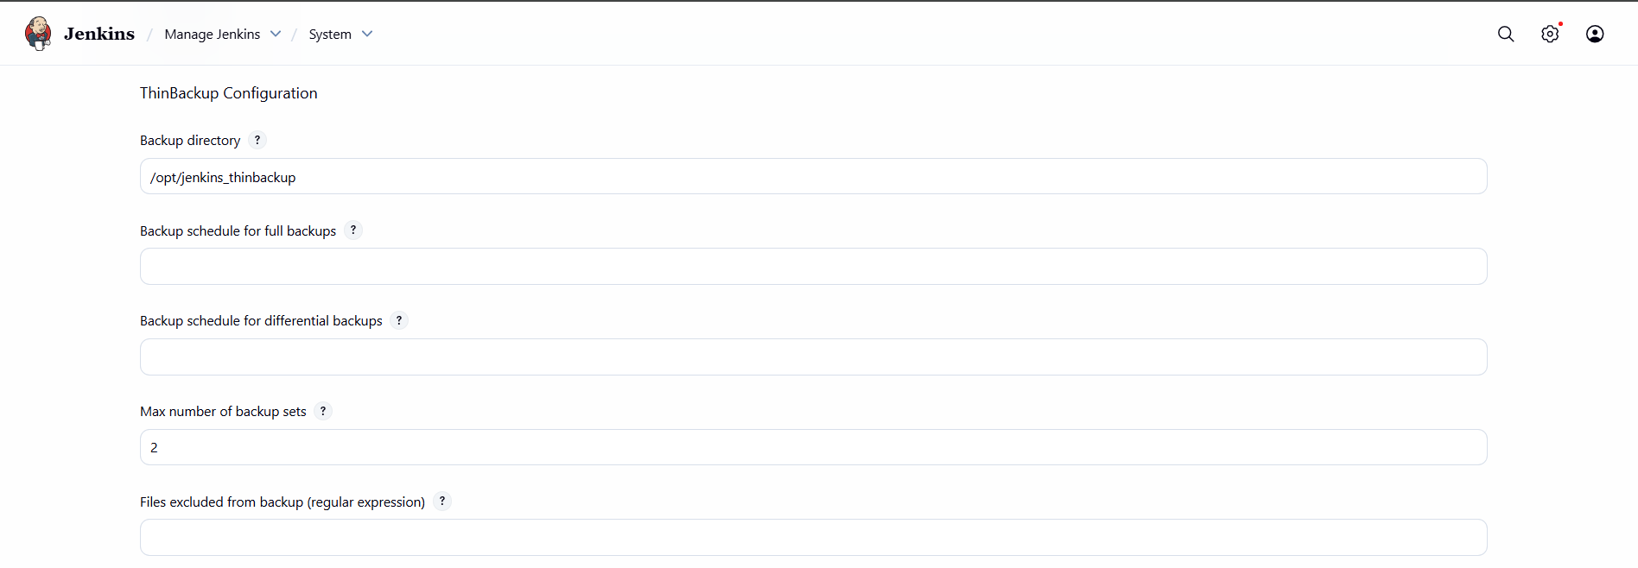
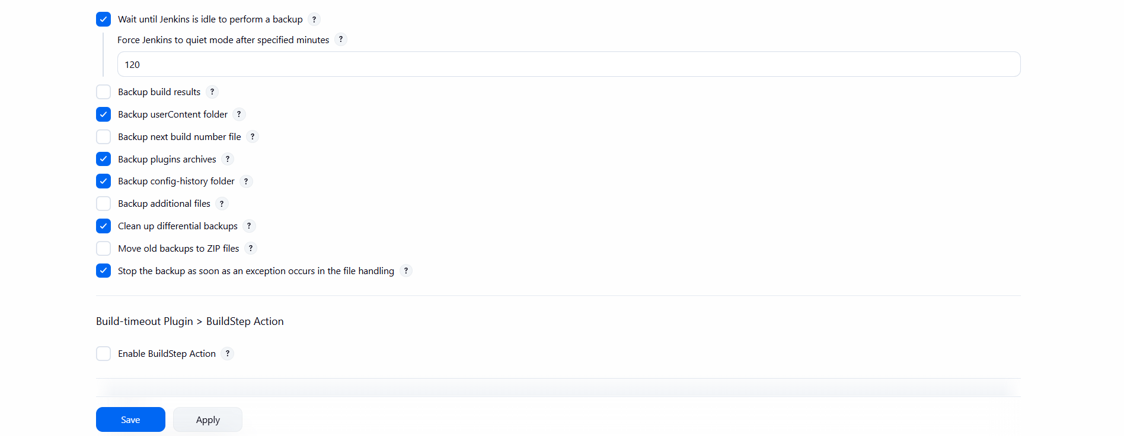

## **Step 3: Take Manual Backup**

1. Go to:

```
Manage Jenkins → ThinBackup
```
2. Click:
✅ **Backup Now**

Jenkins will start creating the backup.

## **Step 4: Verify Backup**

Check the backup directory:

```bash
ls -lh /opt/jenkins_thinbackup
```

You should see folders like:

```
FULL-2025-01-10_15-00
```

Each folder contains:

* jobs/
* plugins/
* config.xml
* users/
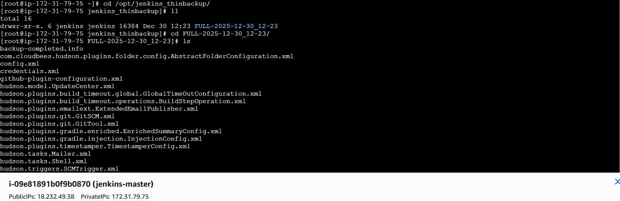

3. Validation Steps

✔ ThinBackup completed successfully
✔ Backup folder created with timestamp
✔ Jenkins configuration and jobs backed up
✔ No errors in Jenkins logs

4. Conclusion

Jenkins backup was successfully completed using the ThinBackup plugin, ensuring safe and automated backup of jobs, configurations, plugins, and user data.

- Setup a new Jenkins server and dump the backup taken in task4.

Step 1 : Create one instance , with java and jenkins installed.

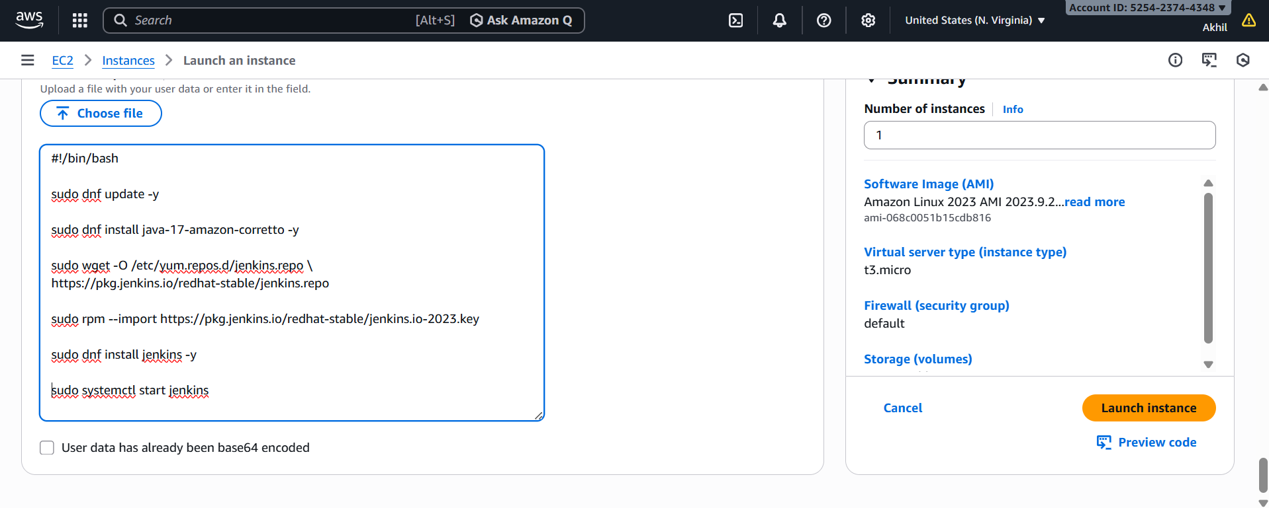
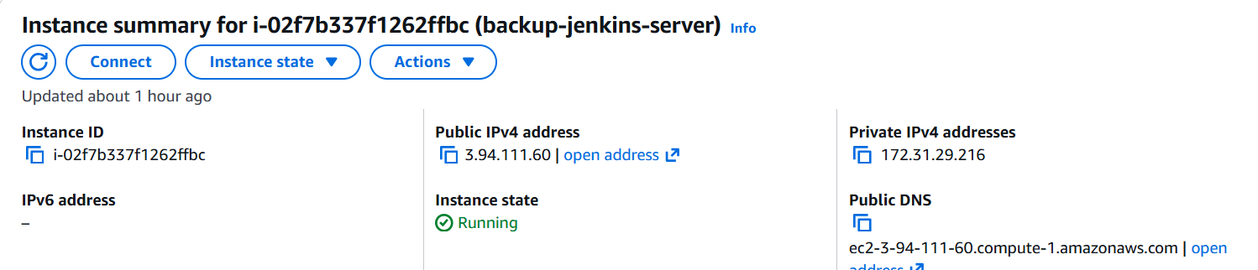

Step 2 : take the backup of jenkins and send that tar.file to new instance created above to /tmp

Step 3 : connect to the new instance , go to /tmp , copy tarfile to /var/lib , go to /var/lib , extract the tar file , restart the jenkins

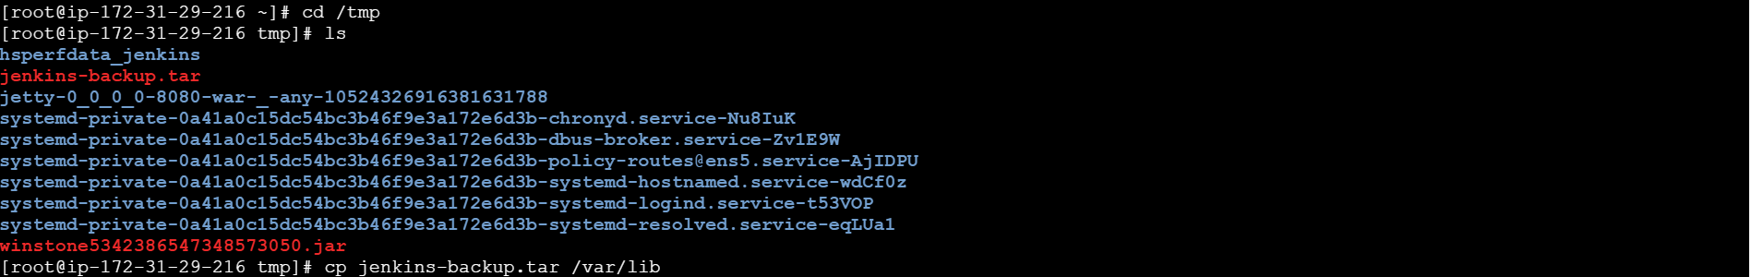
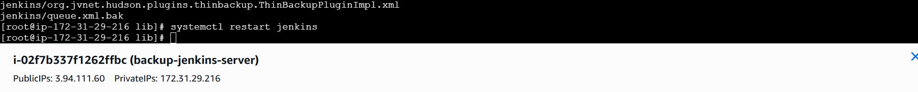

Step 4 : connect to jenkins through new instance

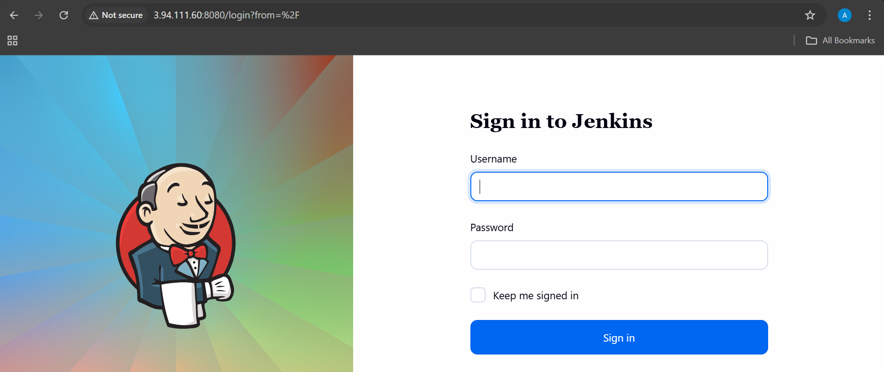

Now we can login with the old credentials and got the backup of jenkins.

